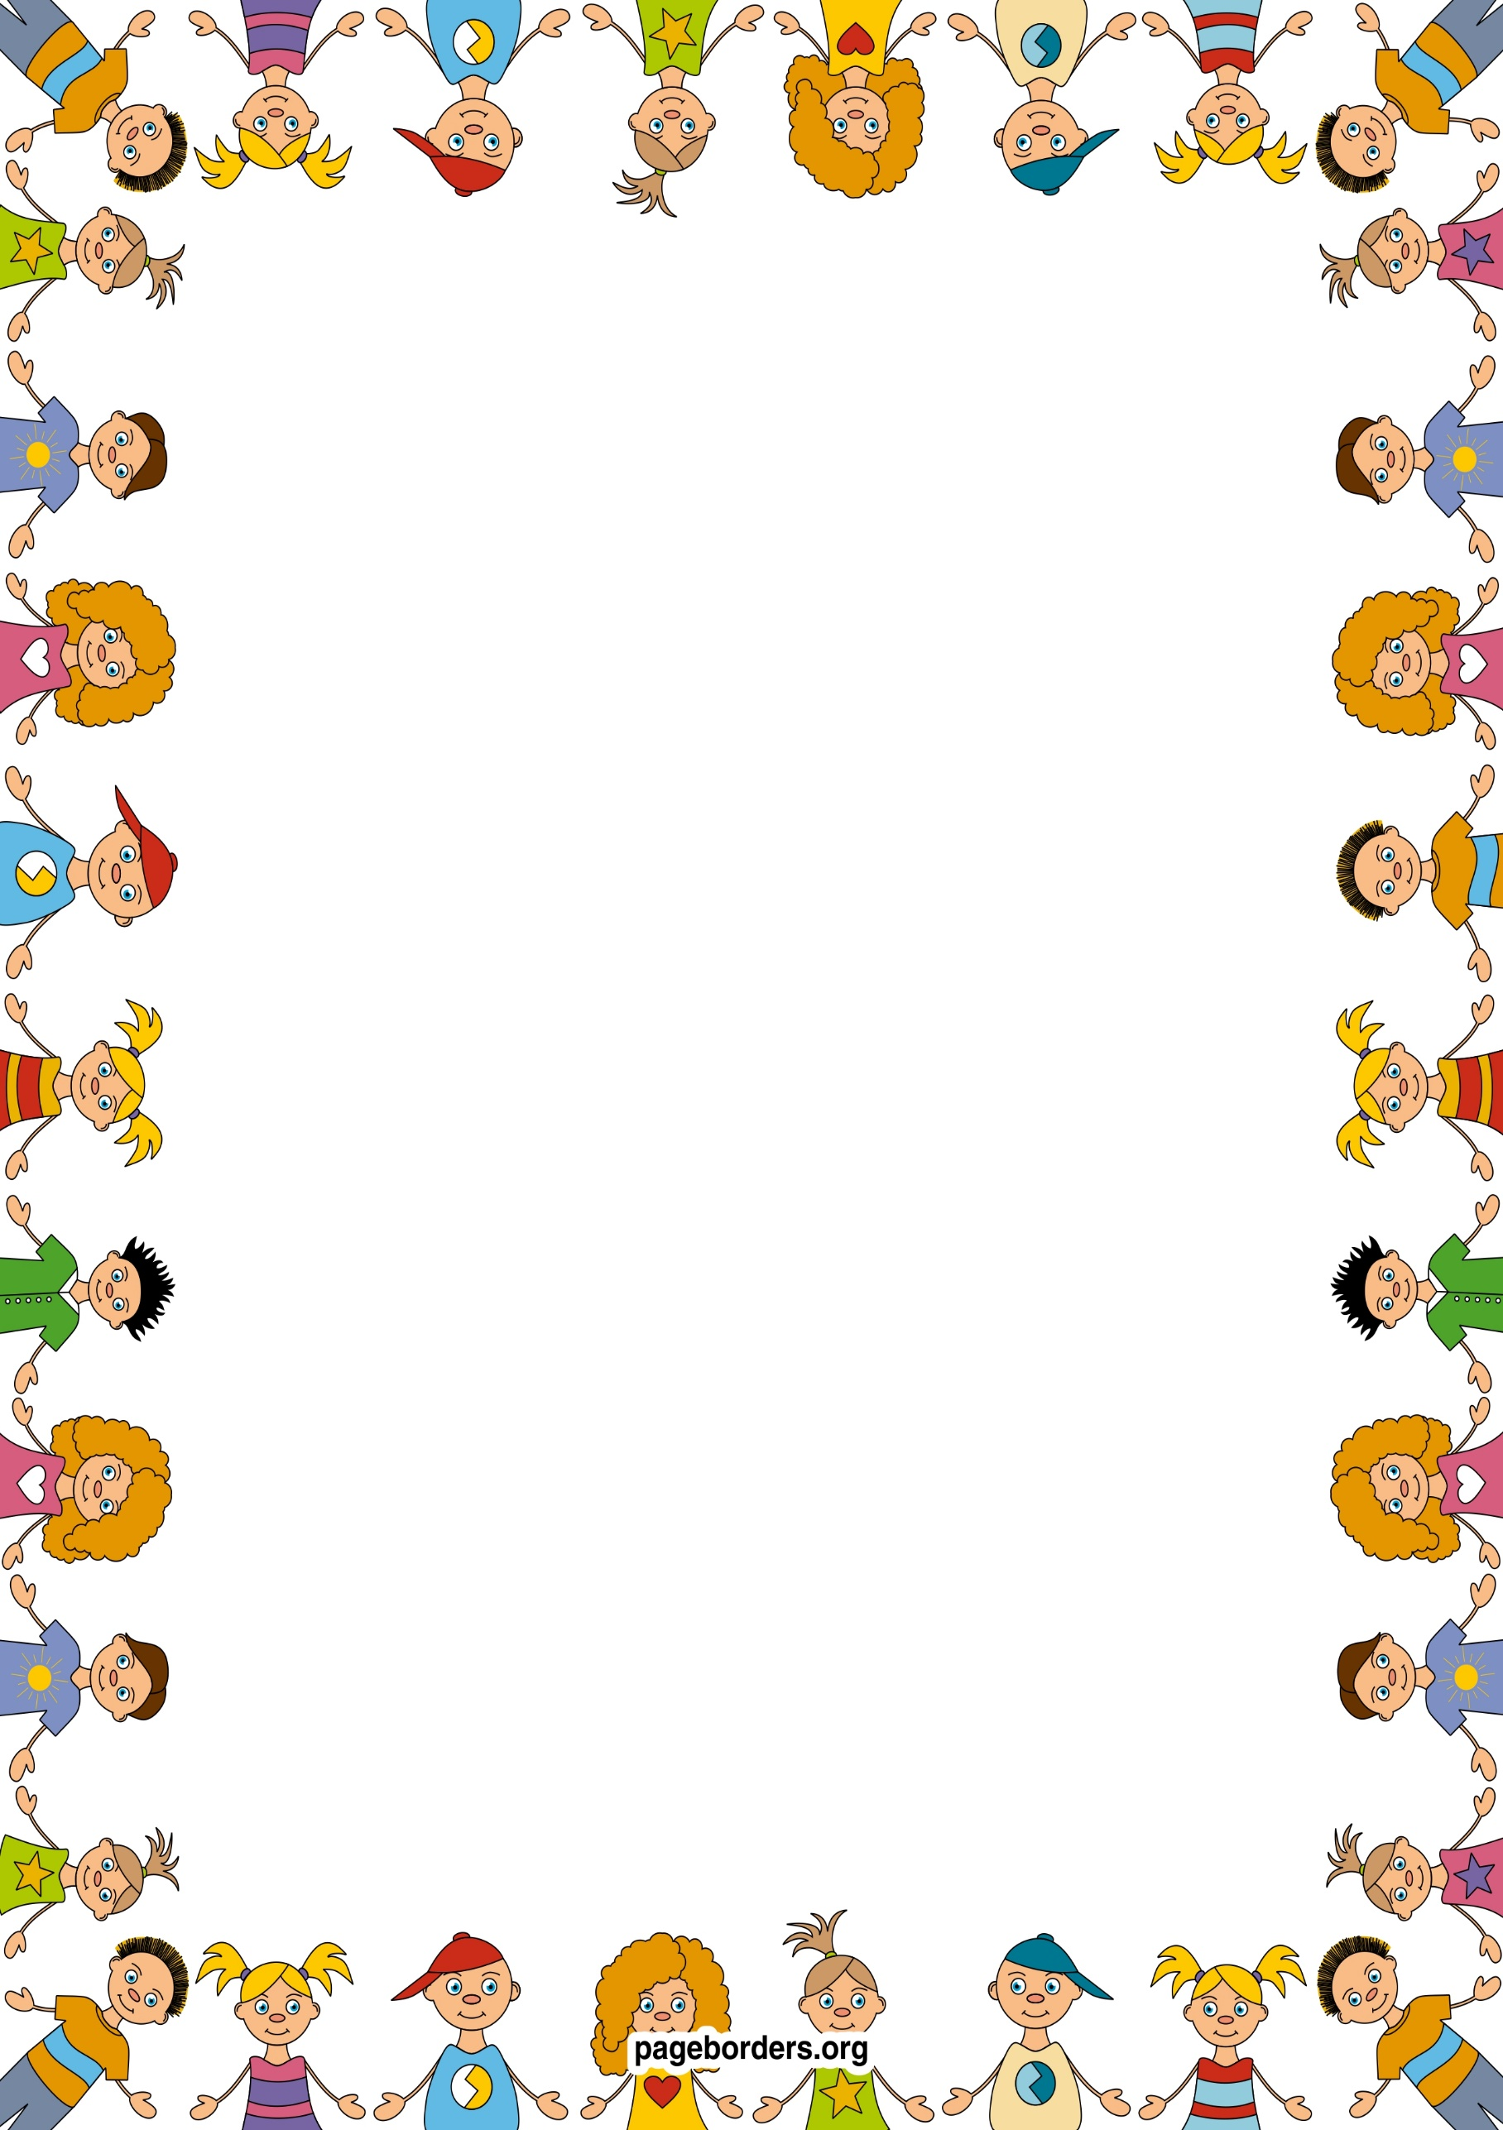

**Special events**

Trip to Garstang Medical Practice.

Nativity

School nurse visit:

**Maths**

Reception:

I will be sorting, investigating pattern and position, learning about shapes, counting, doubling, halving, exploring capacity and learning about time.

Year 1:

I will be looking at number and place value, sequencing and sorting, working out fractions, measuring capacity and volume, counting money, and learning how to tell the time.

Year 2:

I will be looking at number and place value, carrying out simple multiplication and statistics, sorting, working out fractions, measuring capacity and volume, counting money, and learning how to tell the time.

## Geography

I will be comparing and contrasting the UK to Africa.

I will be beginning to develop a sense of empathy with people in other places.

I will be learning some African dance.

Explore movements and shapes from another country

## ICT

* I will be creating a fact file about myself.
* I will be using a computer programme to draw a picture of myself.
* I will be using a computer to help me in my learning.
* I will be using ipads to take photos of my friends.

RE Value ‘Peace’

We will be looking at Jesus’ world. What would life have been like when Jesus lived on Earth?

As we practice our Nativity play and learn about Jesus’ birth we will remember the reasons we celebrate Christmas.

Winmarleigh CE Primary School

Class 1 Curriculum Map – Autumn Term 2

Magnificent Me

## Science

I will be learning about:

* hygiene and growth
* a balanced diet
* our senses and body patterns

## PE

I will be swimming and playing Ultimate Frisbee.

**Music**

I will be focusing on pulse and rhythm, body percussion and singing songs for our nativity.

## PSHE

I will be learning to think about the feelings of others.

I will be learning and talking about my family and other people who are important to me.

DT

I will be making a portrait of myself with:

* pencil
* fabric
* and in the style of in the style of Giuseppe Archimbaldo.

## English

* I will be reading a story with a familiar setting.
* I will be writing invitations, making lists and retelling a story.
* I will be reading information books.