Autumn Term 2020 – 2021 Worship Theme: TRUST
We are thanking God for all his promises to us.
“I will strengthen you. I will help you, I will uphold you.”
based on Isaiah 41:10
Helpers read worries that children sometimes have. All the children then reflected on the displayed bible verses and decided which verse best supported the worried children.

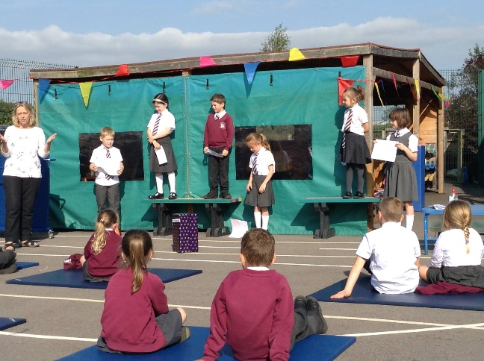
As they left worship, the children were given a key fob showing one of the verses that we had been thinking about in our worship.
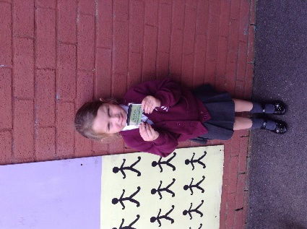
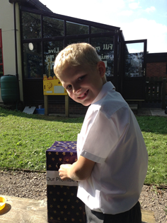
The children were invited to write a secret promise to God that they have made to help someone who is worried about something at the moment. They happily did this during their playtime!
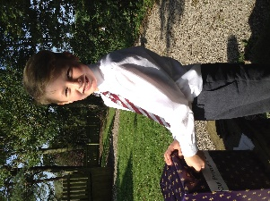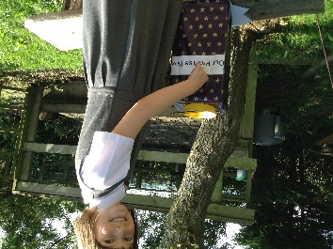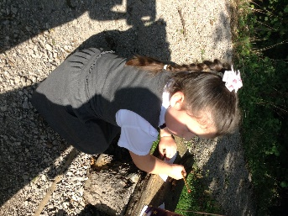
Thank you to Eva, who took these lovely photos!

